# User Guide for CS3235 Project Prototype

# Wearable Products

## By:

## Yeo JunZhi A0067400R

## Chua Wei Kuan A0072749U

## Chua Hong Jing A0074006R

## Tan Swee Khoon A0072707E

### Introduction

This prototype aims to stimulate multiple factor authentications (MFA) over a service. There will be two major components in this prototype namely “Services and Devices” and “Client”.

Services and Devices: This component will stimulate the creation of services as well as user accounts for each service. Devices can also be created in this component.

Client: This component will stimulate the pairing of selected/all compatible devices to be in use during authentication to a service. In addition, it will also stimulate the authentication process of MFA to a service.

### The prototype walk through

#### Step 1: Home page

Visit the page - <http://protoapplist.appspot.com/static/cs3235/index.html>. You will be bought to our main page as shown. As described previously, there are two major components.

**IMPORTANT**: Note that session state does not persist and will be reset upon refreshing the page.

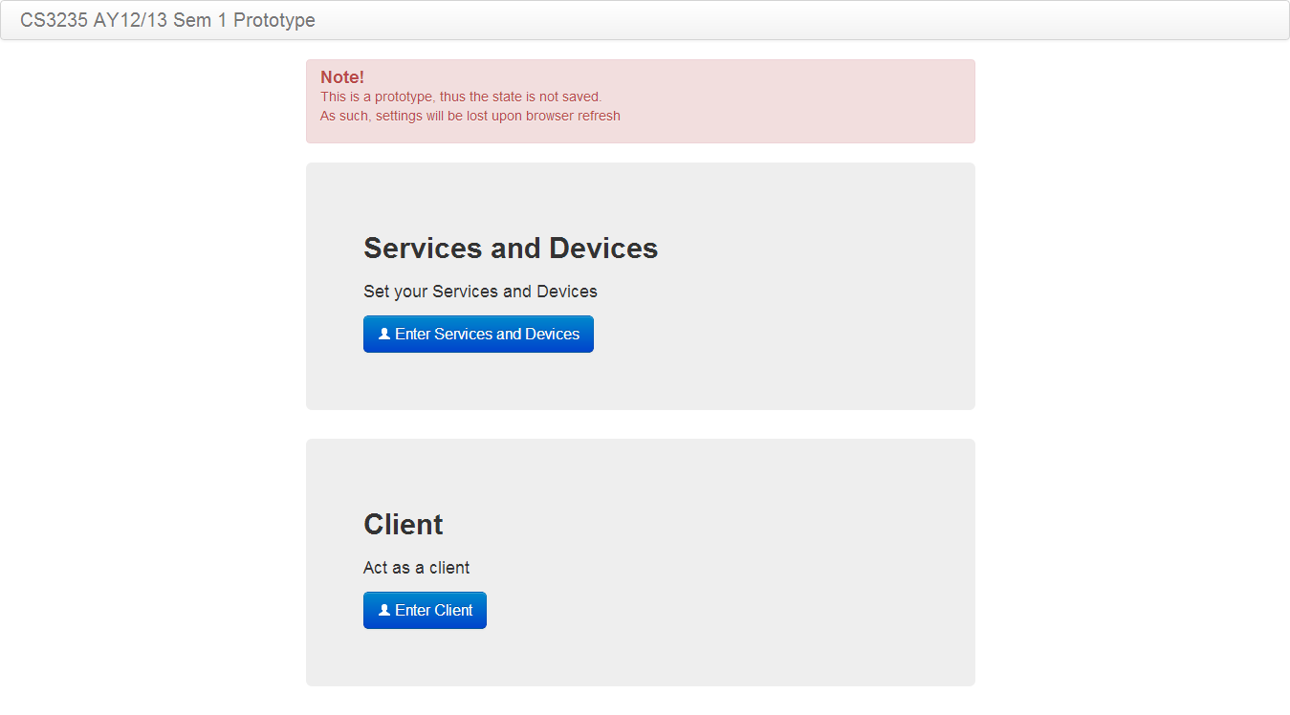

#### Step 2: Services and Devices

We will click on “Enter Services and Devices” button to input some services and devices. After clicking on the button, you will be bought to our Services and Devices homepage as shown below.

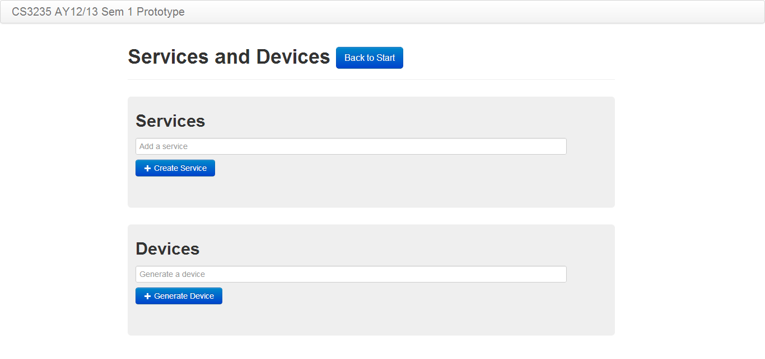

#### Step 3: Creating services

We will first create a few services. To create a service, simply enter the service name in the textbox and click on the “Create Service” button. After which, a notification of the service being created will be display above the Services section. On top of that, list of previously created services together with the newly created service will be displayed as shown.

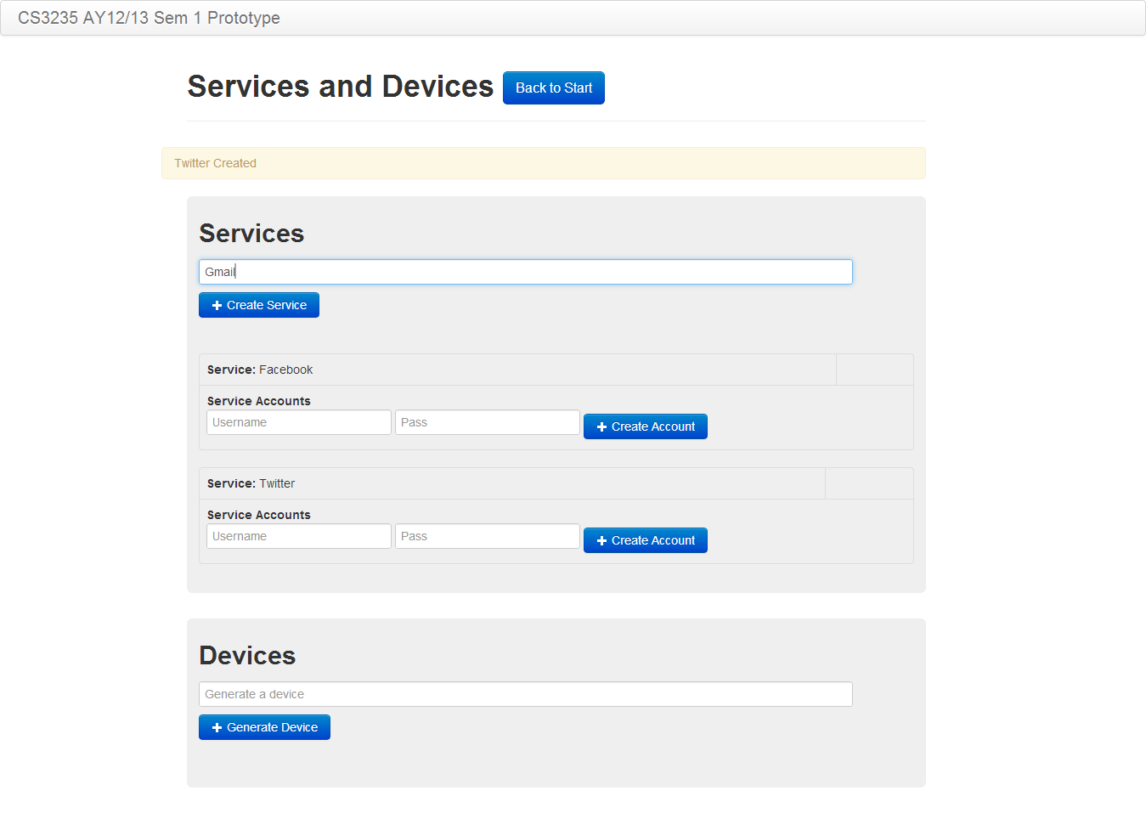

#### Step 4: Creating services account

We will now create user’s accounts for each service. This can be done by filling up the username and password and click on the “Create Account”, a notification will be shown for successful creation. Please note that next to each user there is a device list that is currently empty as no device has been paired with the account yet under that service.

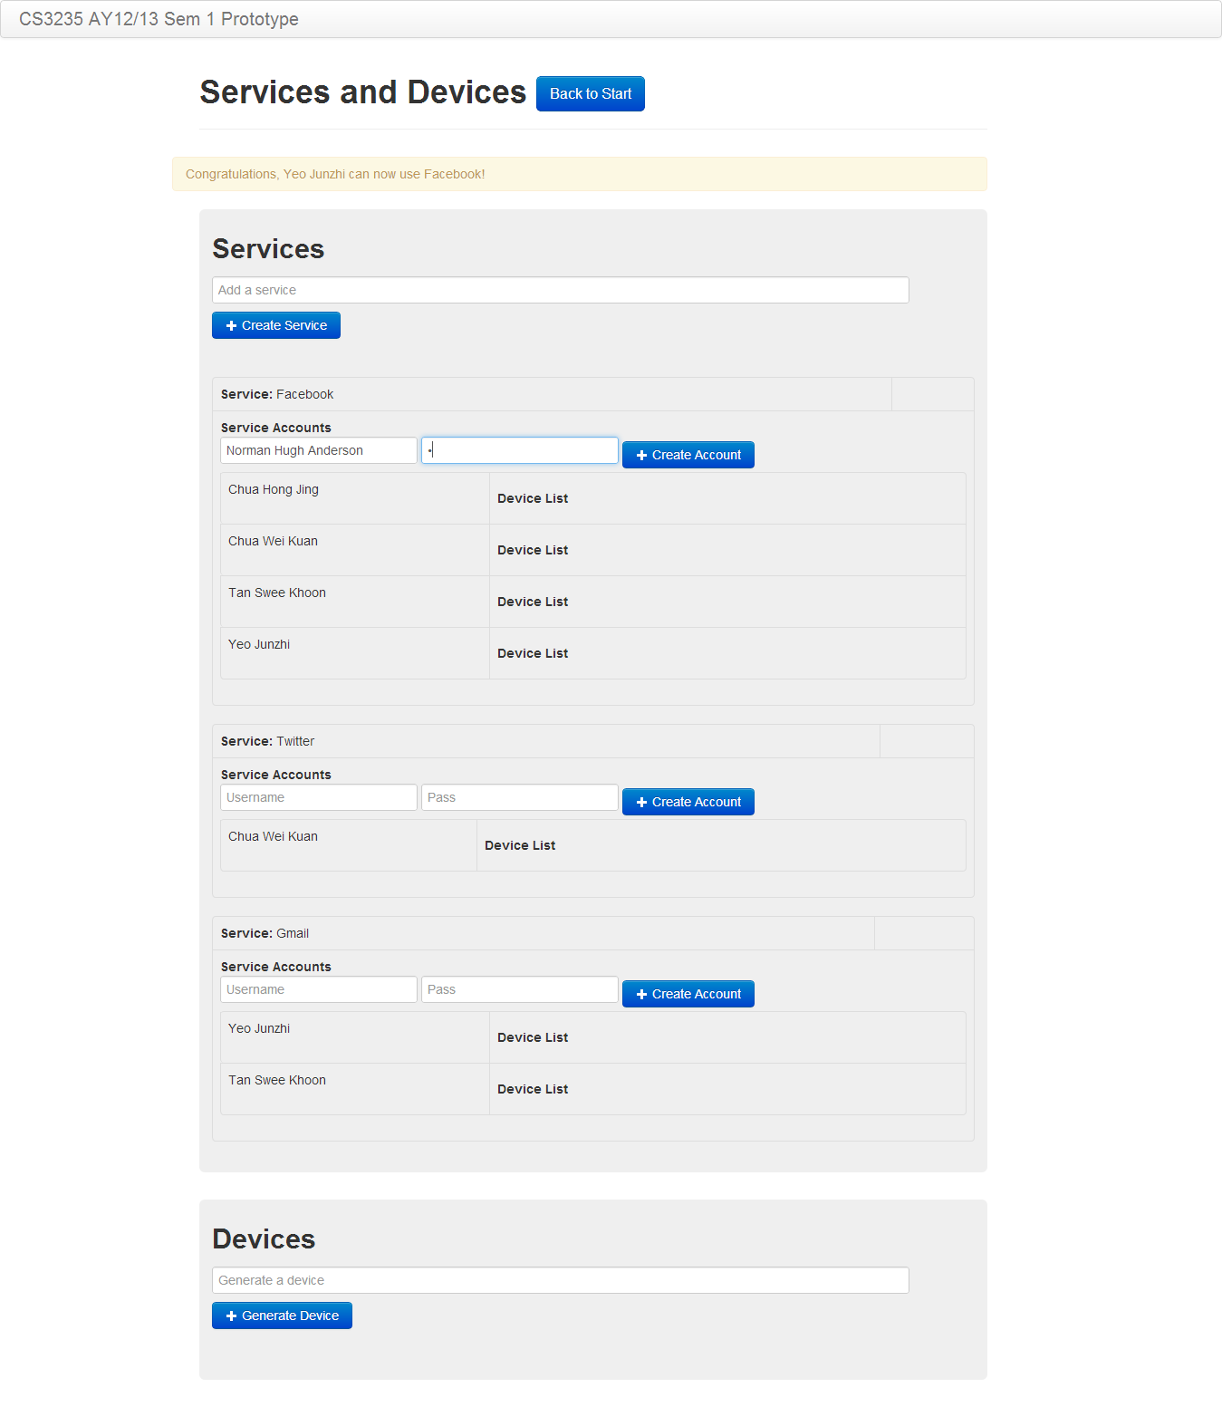

#### Step 5: Creating devices

We will now create a few devices. To create a device, enter the device identifier in the textbox and click on the “Generate Device” button. Note that the type of device and owner of device are not as important since they can be differentiated by the identifier (i.e. John’s watch, Smith’s glasses). After which, a notification of the device being created will be display above the Devices Section. On top of that, list of previously generated devices together with the newly created device will be displayed as shown.

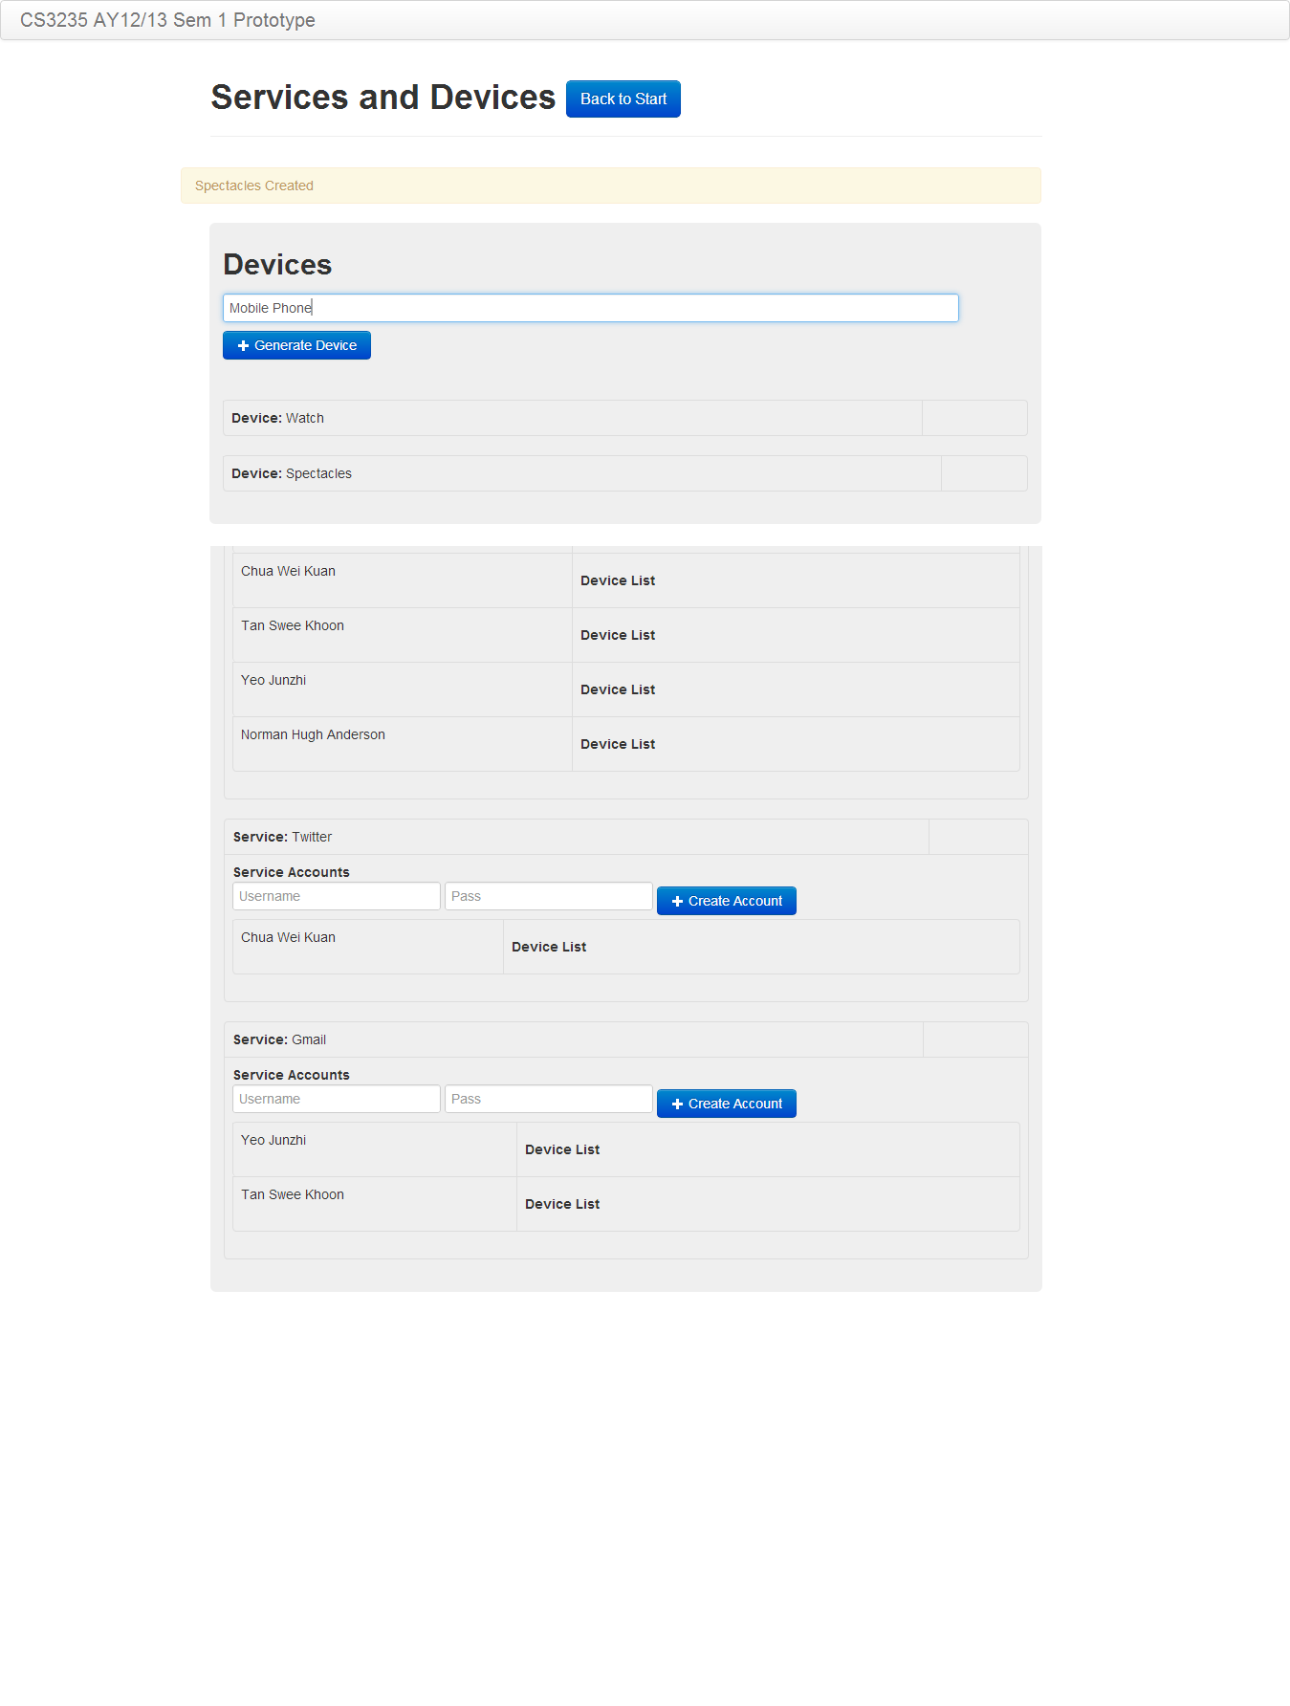

After we have created all the devices we would like to support, we will now proceed to the client section. Do this by clicking on the “Back to Start” button at the top to go back to the main page. We will now click on the “Enter Client” button to proceed to the client component.

#### Step 6: Setup/Pairing devices to services

Select the service, device as well as the user’s account to be paired. Note that the prototype assumes that users are logged in already. Select from the previously created service and device using the dropdown list and enter a user account and click on “Setup” to start the pairing. Successful/Error message will be shown in the black textbox area. Repeat the steps if you wish to pair more device with the selected account/service. After which, you can go back to the “Services and Devices” component to check that they are paired successfully.

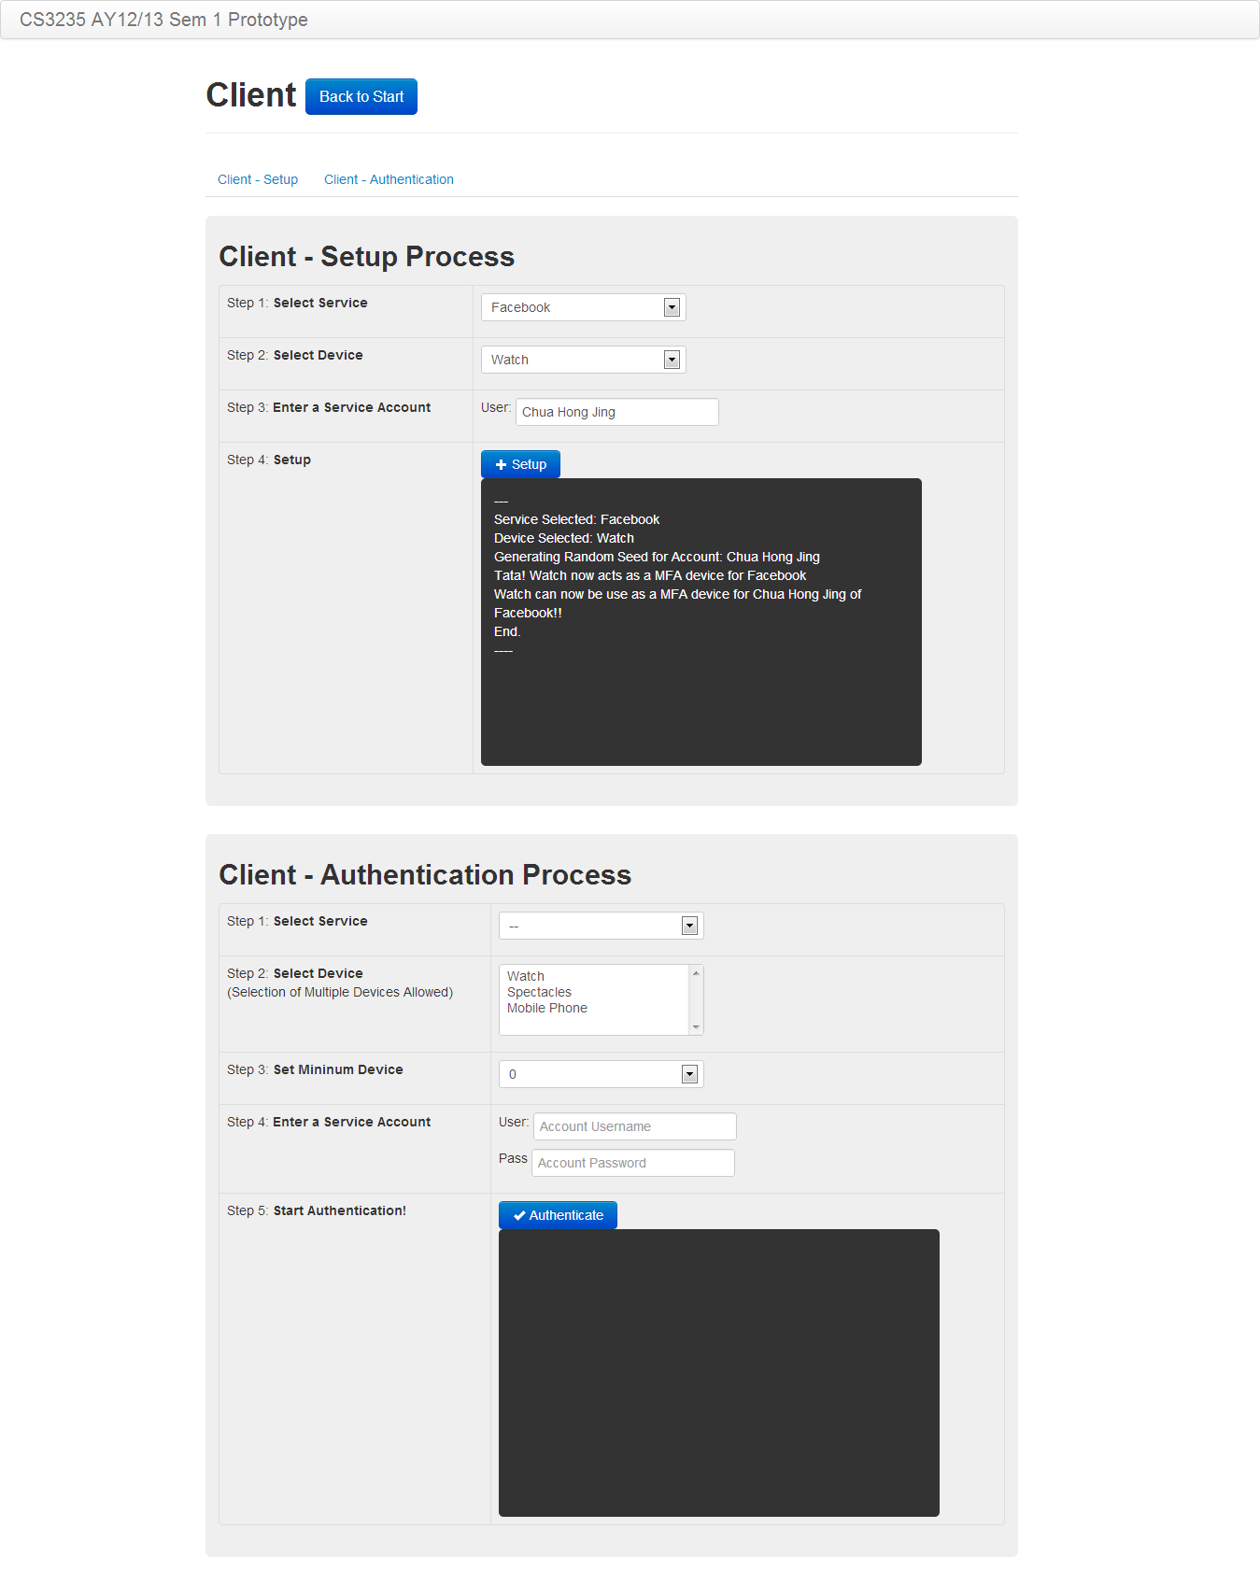

#### Step 7: Verifying paired devices

After you had did the pairing over at the client side, the “Services” section will update all the pairing pertaining to the service, user and device(s). After inspecting that all pairings are correct, we will now proceed to stimulate the authentication process by clicking on the “Back to Start” followed by clicking “Client”.

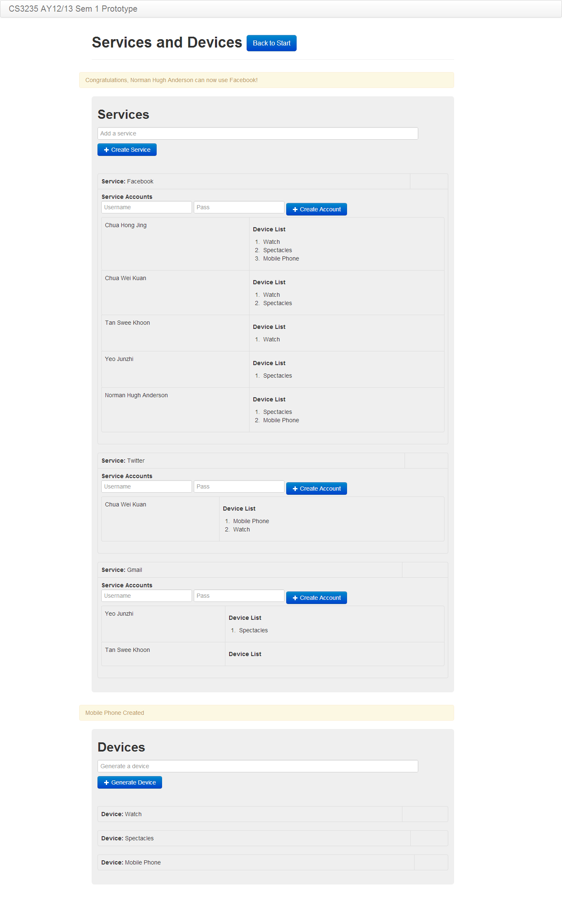

#### Step 8: Authenticate

After setting up the services, devices and pairing of devices, we can now stimulate the authentication process. In this particular section, we have merged the setting of minimum device count together with the authentication. However, note that both operations are independent of each other.

Below is a success login scenario. A value of “3” is used below as the user have paired 3 devices and wishes to force all 3 devices to be used for authentication. Fill in the steps as shown in the user interface and click on “Authenticate to see the successful/error message. You can select multiple devices by holding on to “Ctrl” key and clicking on the device identifier.

Next, you can select only 2 out of 3 devices by unclicking any one of them. Upon clicking authenticate, you will see that authentication has failed. The same reasoning goes for password.

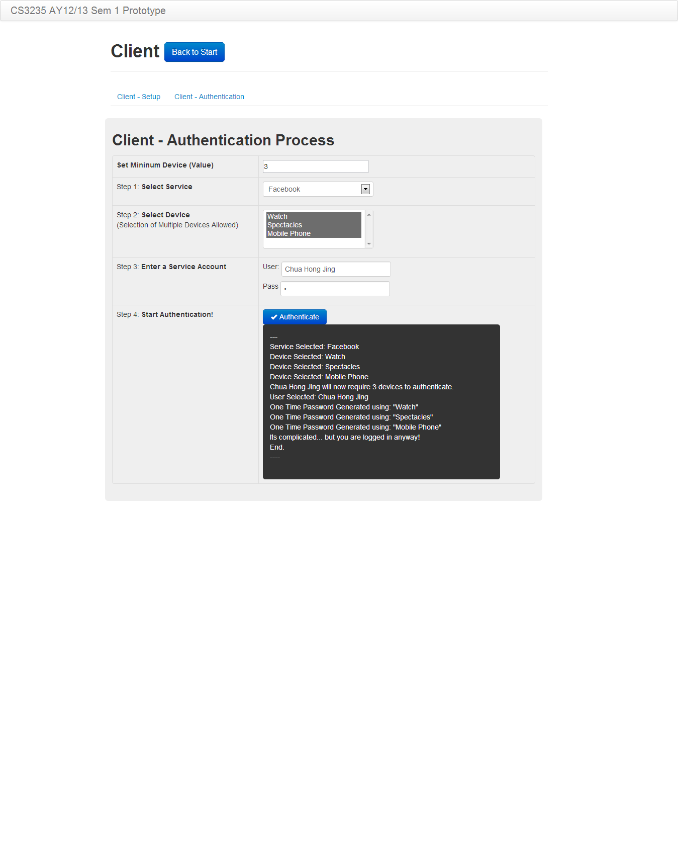

#### Final words

Thank you for reading this user guide and hope you find it interesting. To view the source code, please visit <https://github.com/yeojz/CS3235Project1213.>